Geometry Unit Plan
Kindergarten
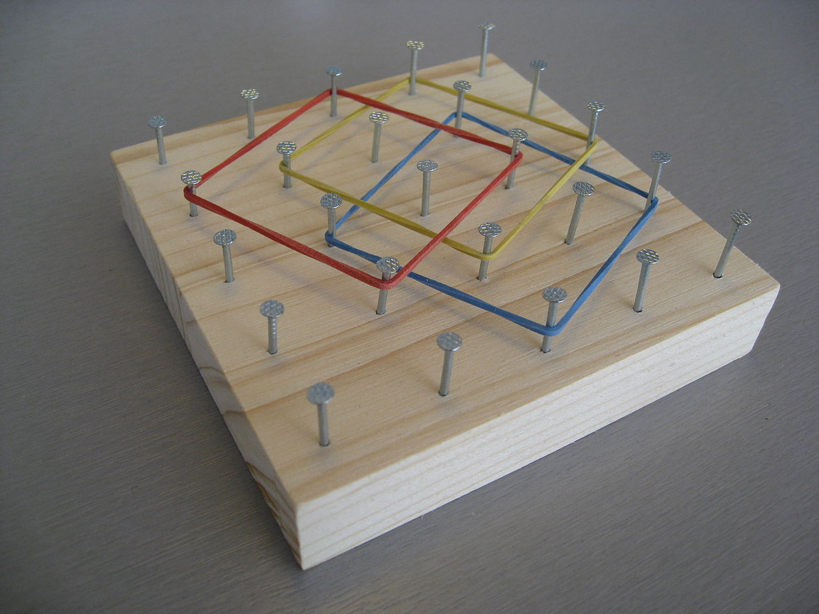
Kristine Sorgenfrei
Schoolcraft Learning Community
kristinesorgenfrei@gmail.com
Molly Turner
Cass Lake-Bena Elementary
mturner@clbs.k12.mn.us
Dawn Cook
Cass Lake-Bena Elementary
dcook@clbs.k12.mn.us

Executive Summary
These lessons are designed to be used throughout the school year to explore the fundamentals and vocabulary of geometry. They address the 5 Kindergarten MN State standards on Geometry concepts. Students will have the opportunity to compose and decompose shapes and explore attributes of them. These lessons can be stand alone lessons and can be used throughout the year to supplement your current curriculum.

Minnesota Standards Addressed
K.3.1.1 Recognize basic two- and three-dimensional shapes such as squares, circles, triangles, rectangles, trapezoids, hexagons, cubes, cones, cylinders and spheres.
K.3.1.2 Sort objects using characteristics such as shape, size, color and thickness.
K.3.1.3 Use basic shapes and spatial reasoning to model objects in the real-world. For example: A cylinder can be used to model a can of soup. Another example: Find as many rectangles as you can in your classroom. Record the rectangles you found by making drawings.
K.3.2.1 Use words to compare objects according to length, size, weight and position. For example: Use same, lighter, longer, above, between and next to. Another example: Identify objects that are near your desk and objects that are in front of it. Explain why there may be some objects in both groups.
K.3.2.2 Order 2 or 3 objects using measurable attributes, such as length and weight.

Table of Contents

Topic | Title | Page
Pre-Test/Post Test |  | 4
Lesson 1 | Making Shape Pictures | 5
Lesson 2 | Making Shape Pictures Cont. | 9
Lesson 3 | Making Clay Shapes | 11
Lesson 4 | Pattern Block Puzzles | 12
Lesson 5 | Making 3D Clay Shapes | 21
Lesson 6 | Build a Cube | 22
Lesson 7 | Squares and Cubes | 23
Lesson 8 | Quarter Turns | 24
Lesson 9 | Square Search | 25
Lesson 10 | What’s Your Guess | 26
Lesson 11 | Marshmallow Shapes | 27
Lesson 12 | Marshmallow Shapes Cont. | 29
Lesson 13  Input and Output | Little Red Hen Shapes Pizza | 31
Lesson 14 | Pattern Block Barrier Game | 34
Lesson 15 | Shapes on the Geoboard | 36
Resource Citations |  | 38

Pre-Test/Post Test:
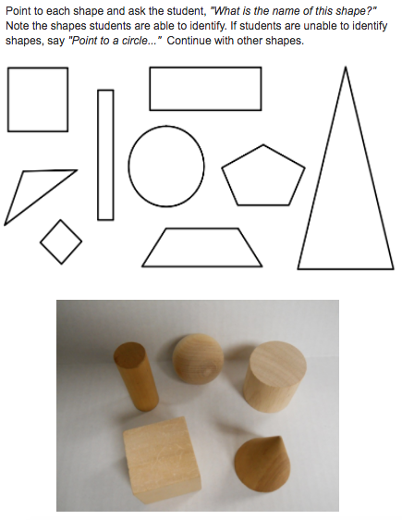

Resource: http://www.scimathmn.org/stemtc/frameworks/k31-shapes

Lesson 1
Making Shape Pictures
Learning Target: I can create a picture using shapes.
Materials: shape cutouts (cut out), paper, crayons, glue sticks
Launch: Show students a bike. Give students a minute to think-pair-share and discuss what they know about bikes or stories they might have. After they are excited, share with them that bikes work because of shapes. See if any students can identify a shape on the bike (triangle frame, circle wheel, etc.). Grab a big piece of paper and 2 circle shape cutouts. I could make a picture of my bike if I use these 2 circles as wheels. Show students how to glue the circles next to each other like the wheels. “Does this look like a bike yet?” Draw in the frame and other parts of the bike, talk about how you could add more details such as trees or a path and so on. Their job during work time today will be to create their own shape picture for our book! Before letting them get to work, have them brainstorm what they could make out of a rectangle. Ideas could be things like a school bus, house, building, etc.
Explore: Review the procedure for creating a shape picture. First, find paper and a shape. Then, glue on the shapes. Next, add details to the picture to make it into something. Remind students that they should be doing quality work during this time and to take their time as this will be added to a class book of shapes. Remind students that they will have 2 days to work on their pictures.
Share: Have a few students share their shape drawings discussing what shapes they used and what they turned them into.
Summarize: Remind students that we see shapes everywhere in the world. Their job tonight is to see what shapes they can find at home.
Resource: Investigations in Number, Data, and Space 3. Pearson Education Inc., 2017.

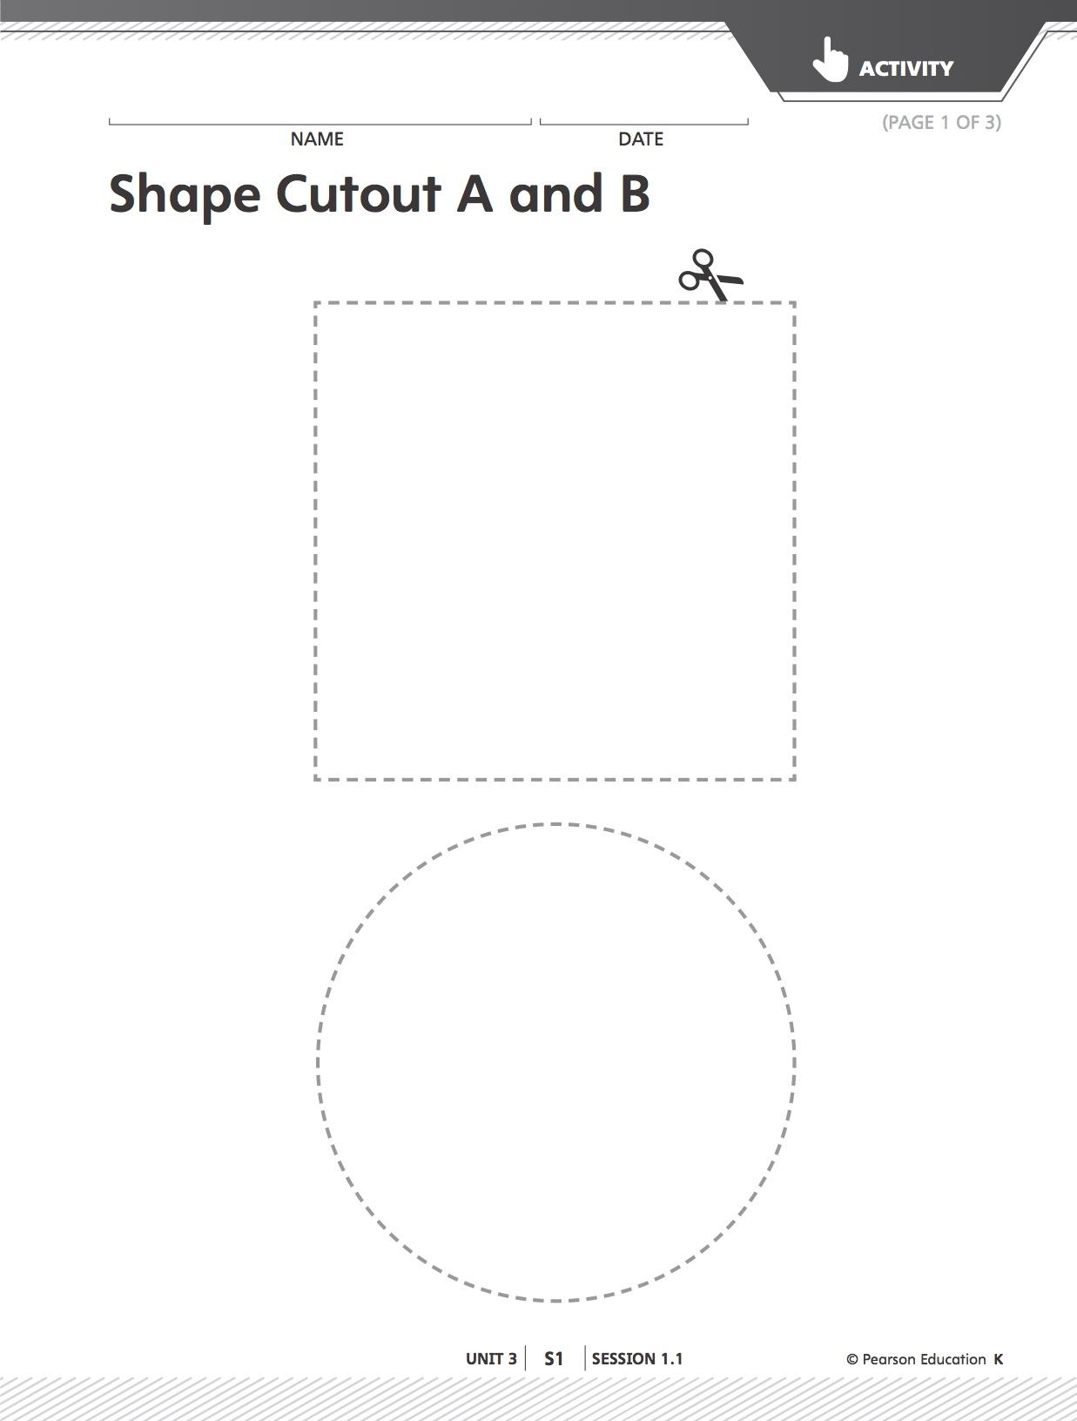

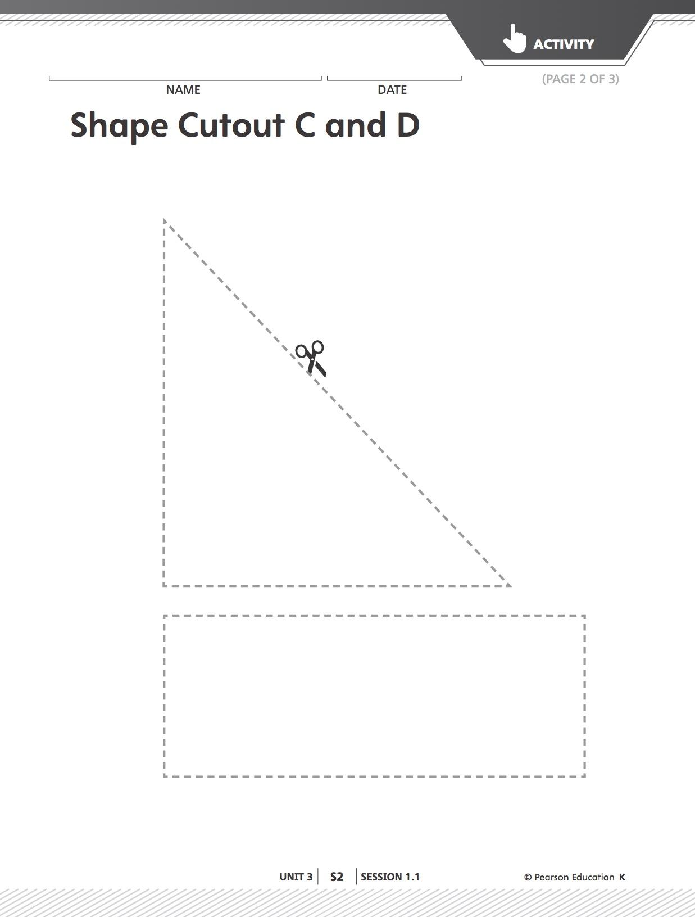

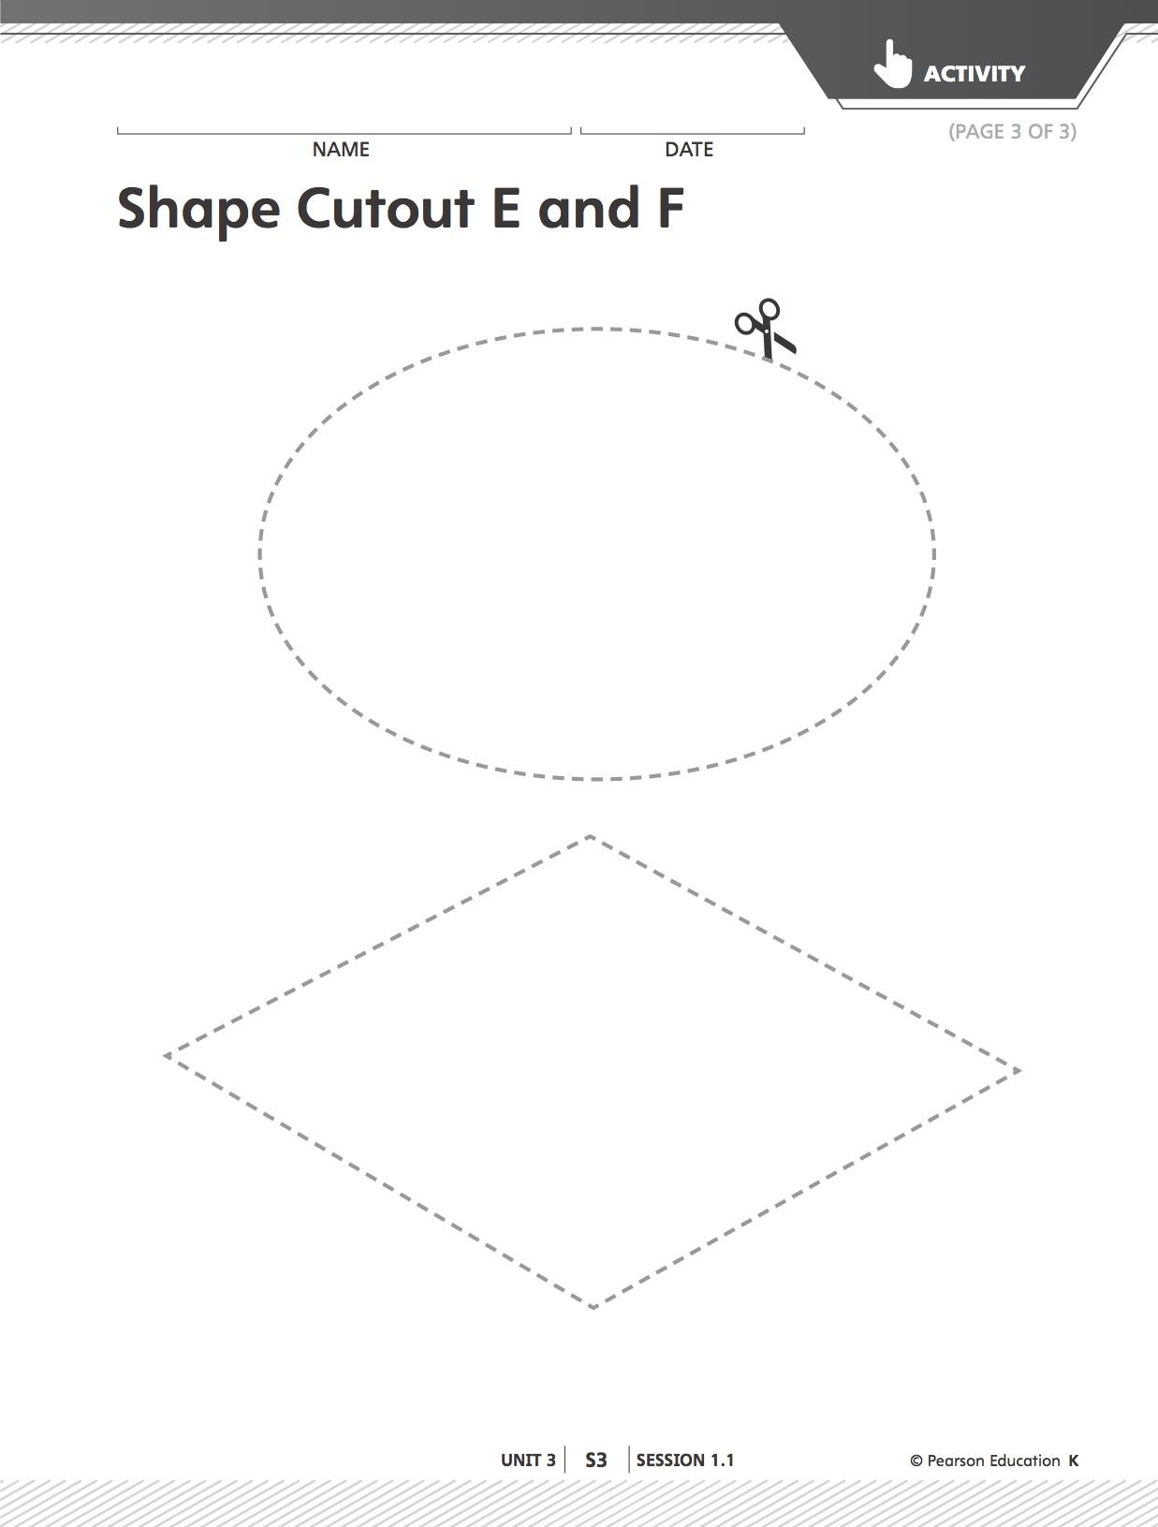

Lesson 2
Making Shape Pictures Cont.

Learning Targets: I can create a picture using shapes. I can describe my shape using shape words.
Materials: materials from previous lesson and text boxes.
Launch: Show students your picture of the bike you made yesterday with some more details added to make it a final product. Ask students to share why they think this is a final product of my picture (should have neat coloring, easy to tell what it is, lots of colors, many details, etc). Show them a blank text box that they will use to describe their picture. Have them help you fill it in. It should read “A circle is a circle when you add a triangle and handlebars then it is a bike.” Tell them that today they will have a chance to turn their shape pictures into final products and add text for our book. They should raise their hand when they are ready to have an adult help them write, but they should be thinking about the shapes they used before they ask for help writing.
Explore: Students can work on their pictures and getting help writing. When they are done they should glue the text onto their pictures. If they have time they can work on creating another shape picture, but should try to use more than one shape in this one.
Share: Have a few other students share their completed pictures and text.
Summarize: When the book is completed, read it to the students. Congratulate them on their hard work and all the shape creations they made.
Resource: Investigations in Number, Data, and Space 3. Pearson Education Inc., 2017.

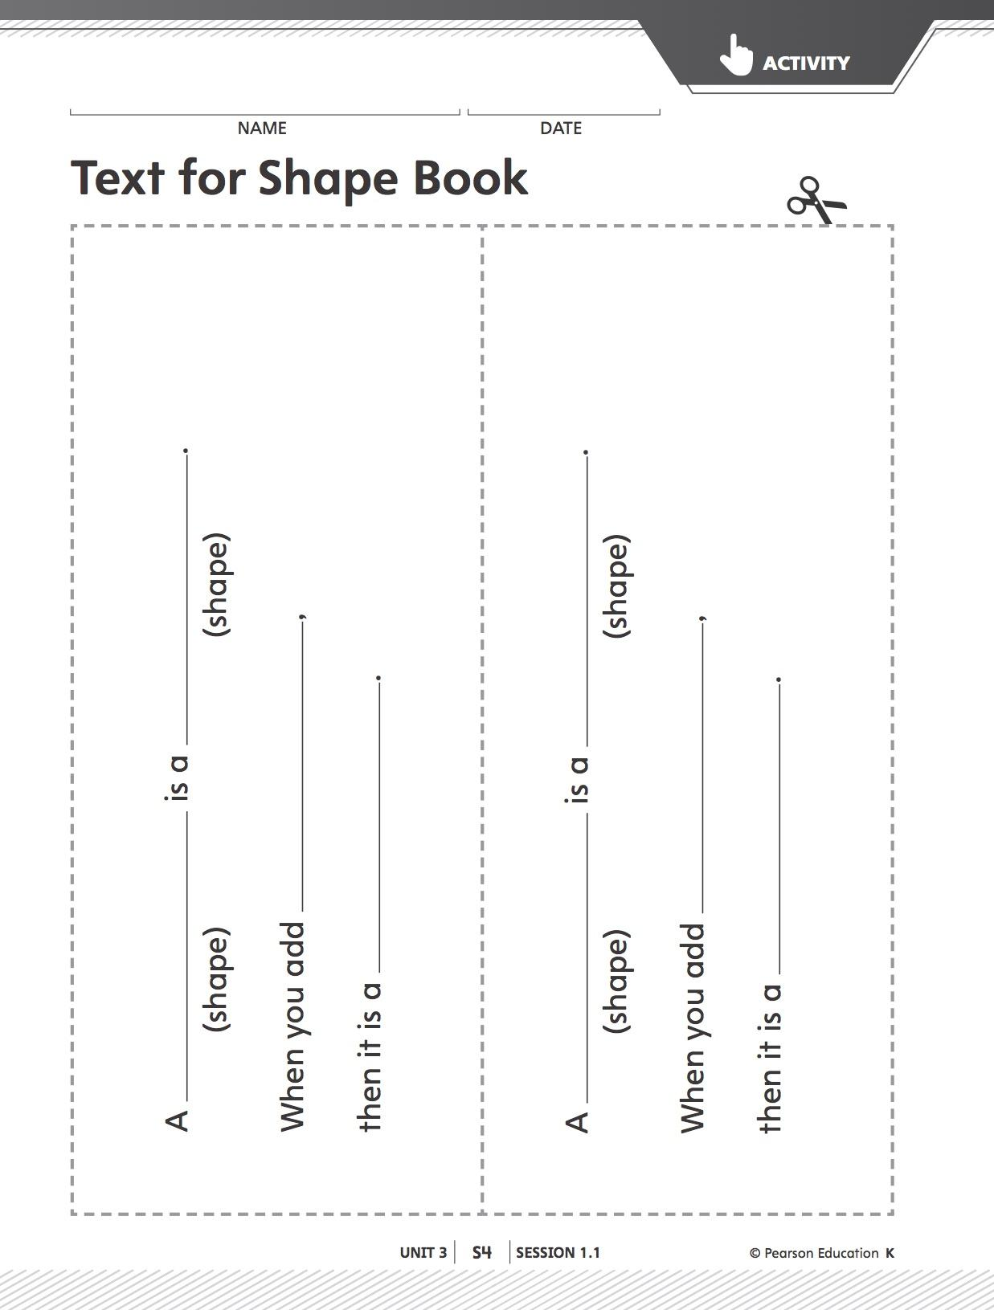

Lesson 3
Making Clay Shapes
Learning Targets: I can create 2D shapes using clay.
Materials: cardboard squares or trays, clay for each student, shape anchor chart, shape cutouts
Launch: Show students the shape cutouts they used to make their shape picture book. Remind them about how they created so many different things with these shapes. Have students review the shape names as you go through them. Tell them that today they will be creating these shapes using a new math tool, clay! Ask if anyone has used clay before and what they have created using it. Create an anchor chart about how to use the clay in the classroom (only take a handful, make sure it stays on the tray, pick up pieces when done, put it back in the container, etc.) Then show students how to make a clay snake. Tell them that they will use these clay snakes to make their shapes today. Ask them to help you make a triangle. “How many clay snakes will I need?” Create a triangle using the clay as a model.
Explore: Students will have work time to create as many shapes using the clay as they can. They can use the shape cutouts or shape posters to help them come up with ideas. At the end of work time they will have to share one shape in circle. Give them time to create and 5 minutes before circling up, remind them to finish one shape to share.
Share: Every student should have a clay shape in front of them. Ask anyone’s shape has curved or round edges. Have those students put their shapes in a group. Now ask if anyone has 3 edges and put those in a group. Keep grouping them until each shape is in some sort of group. Ask students what is special about one of the groups. What is different about the shapes in a group?
Summarize: Discuss if it was easy or hard to make shapes using clay and why. Were there any shapes that were really hard to create? Make sure to review shape names and attributes before having the students put their clay and trays away.
Resource: Investigations in Number, Data, and Space 3. Pearson Education Inc., 2017.

Lesson 4
Pattern Block Puzzles
Learning Targets: I can find combinations of shapes that fill an area.
Materials: Pattern Block Puzzle Sheets, pattern blocks
Launch: Show students Pattern Block Puzzle 1. Tell them that this is a puzzle that they will have to figure out how to fill. Use a doc cam or the online part of Investigations to work as a class to fill it out. Have one student come up at a time and fill in part of the puzzle. If it doesn’t come up when the class is working together, remind students that to finish a puzzle all parts must be filled in and there cannot be any extra pieces. When you have finished the puzzle see if anyone can come up with another way to fill it. Take away the hexagons as an option and fill in the puzzle another way. Tell students that for every one of these puzzles there is more than one way to fill it in and to be creative.
Explore: Students will work on solving different pattern block puzzles. Tell them that when the finish one they can get a new puzzle or try to solve one another way. Watch and make sure that students are filling in all of the space and not going over the edges. See what students can use different shapes to fill in a space. Ask students to identify the shapes they are using. Find a student or two with creative solutions to save their puzzle to share.
Share: Have the students who had creative solutions to puzzles to share. Have them discuss why these ways work and what shapes can be combined to make new shapes.
Summarize: Record some examples of combined shapes to use in future lessons such as 2 trapezoids make a hexagon).
Resource: Investigations in Number, Data, and Space 3. Pearson Education Inc., 2017.
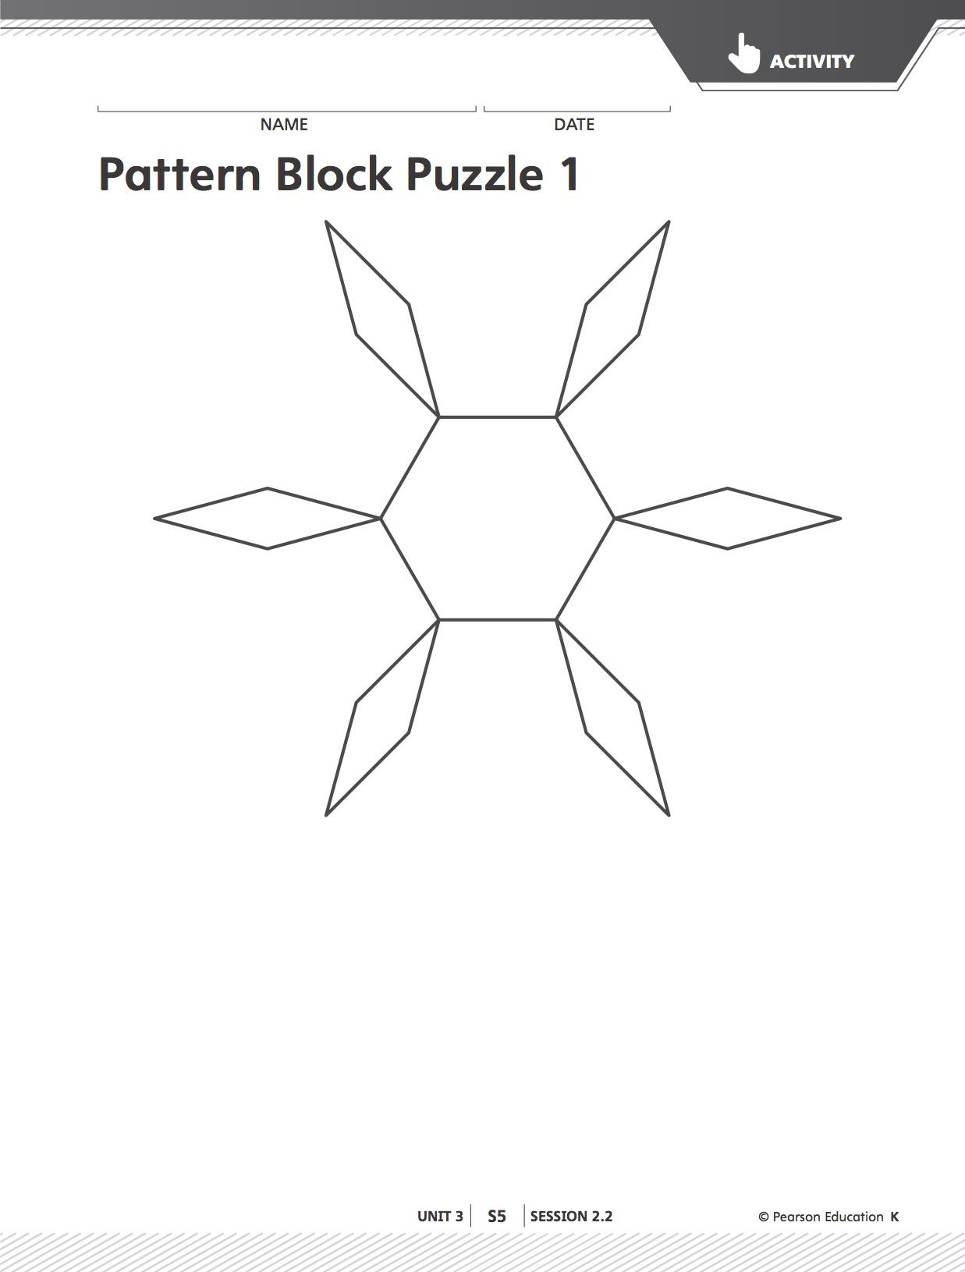

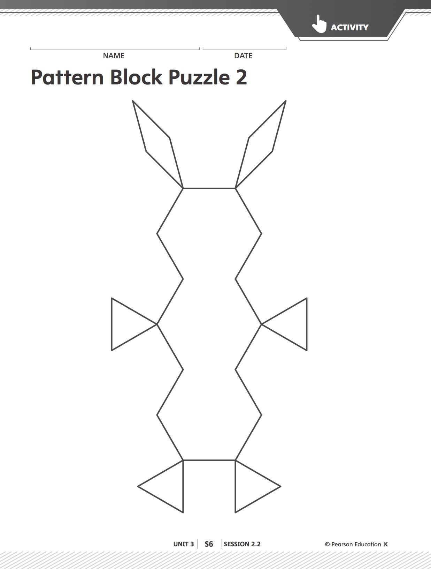

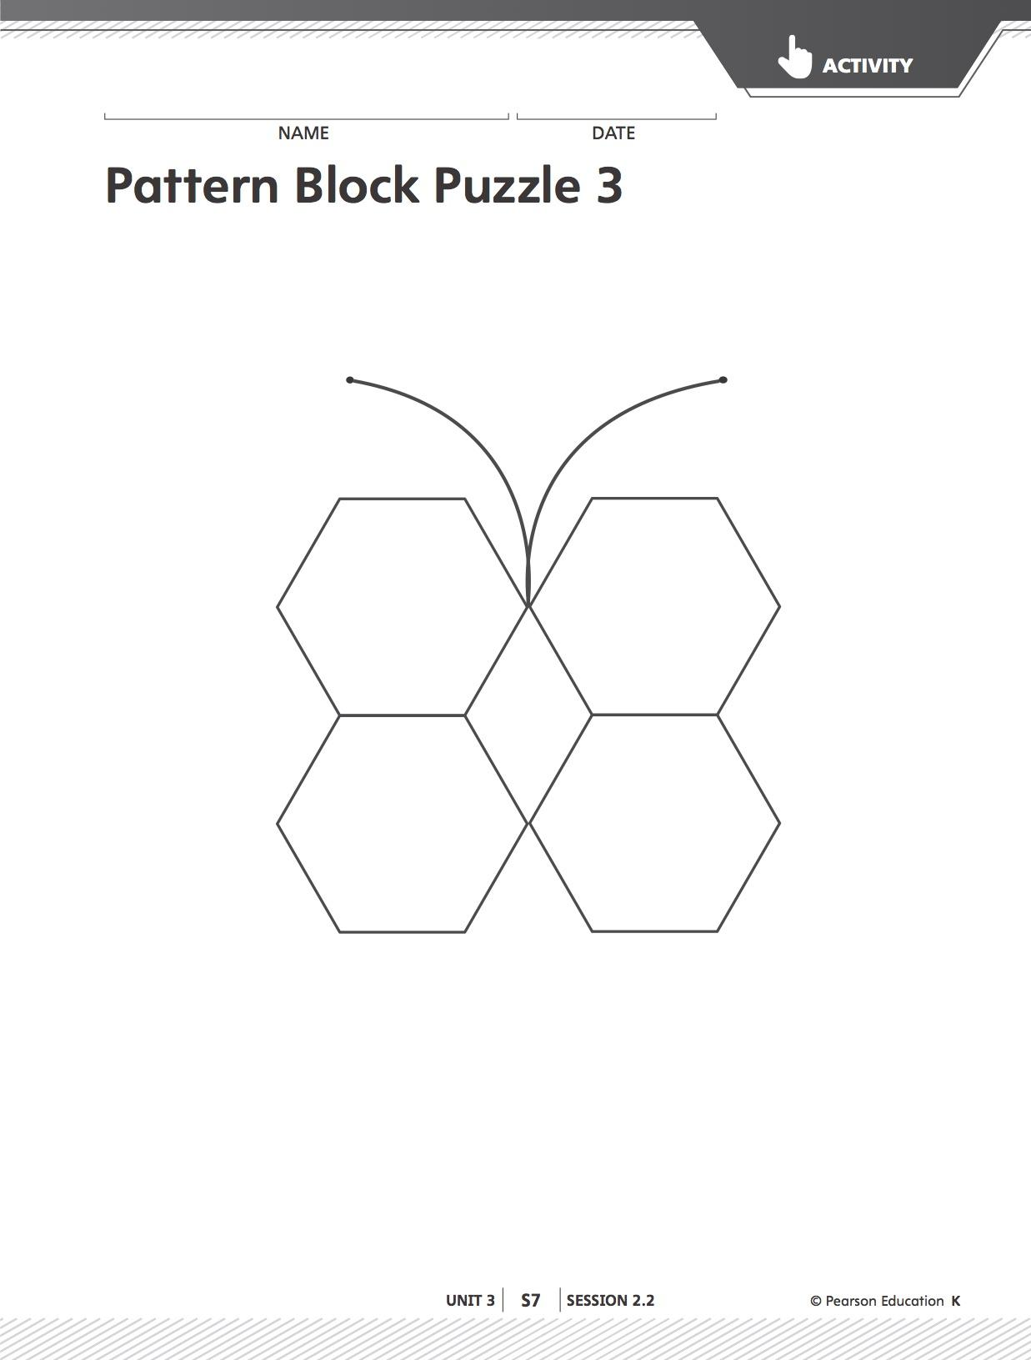

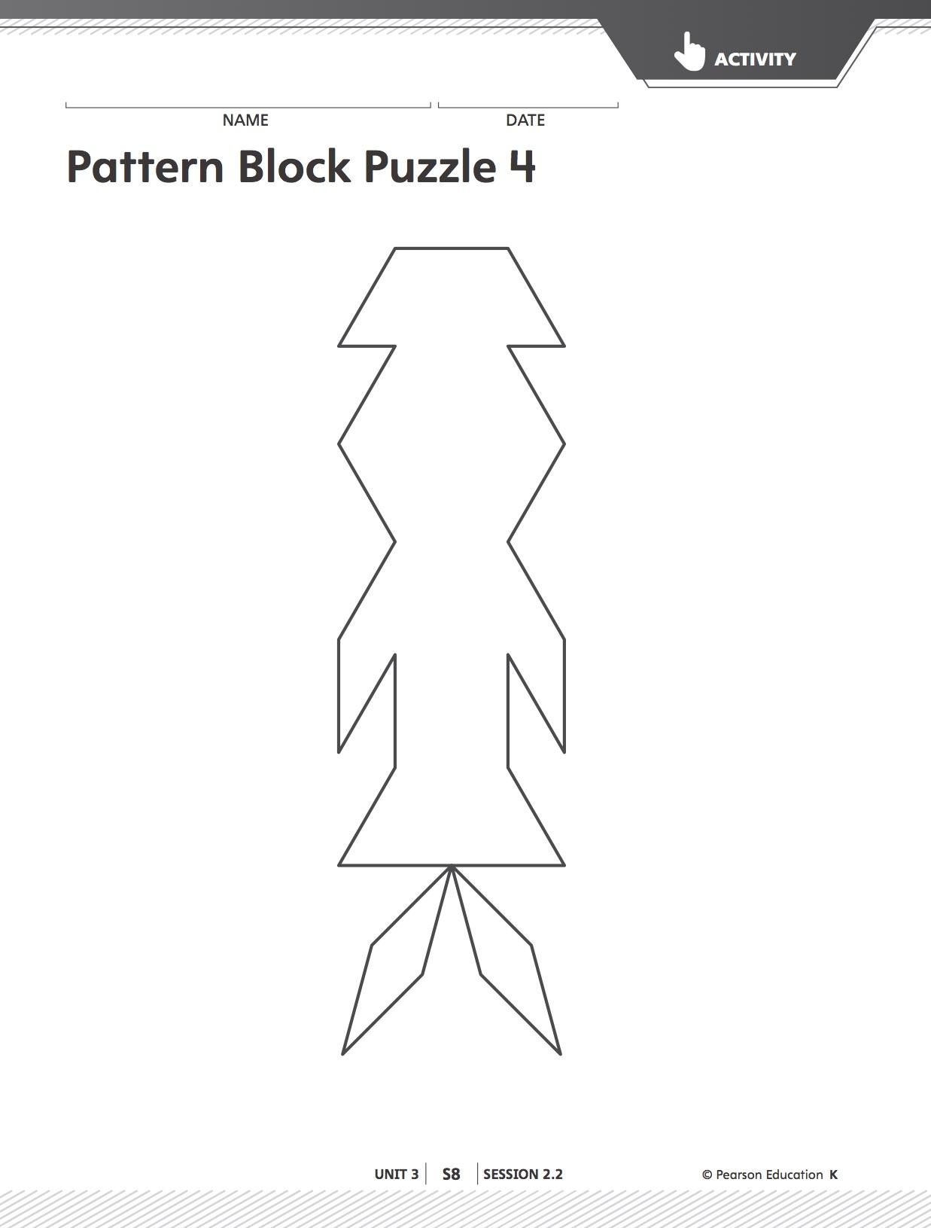
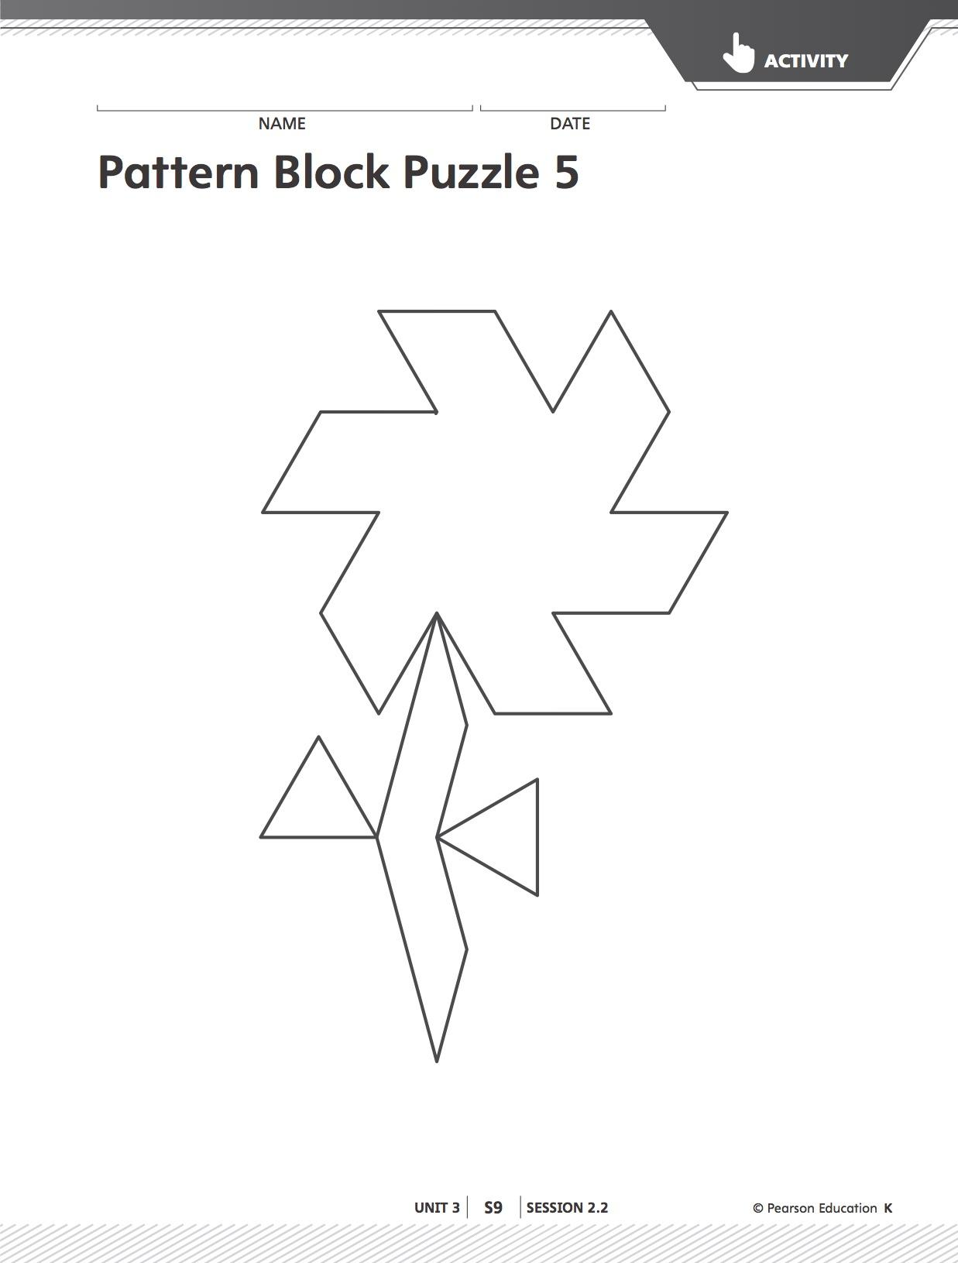

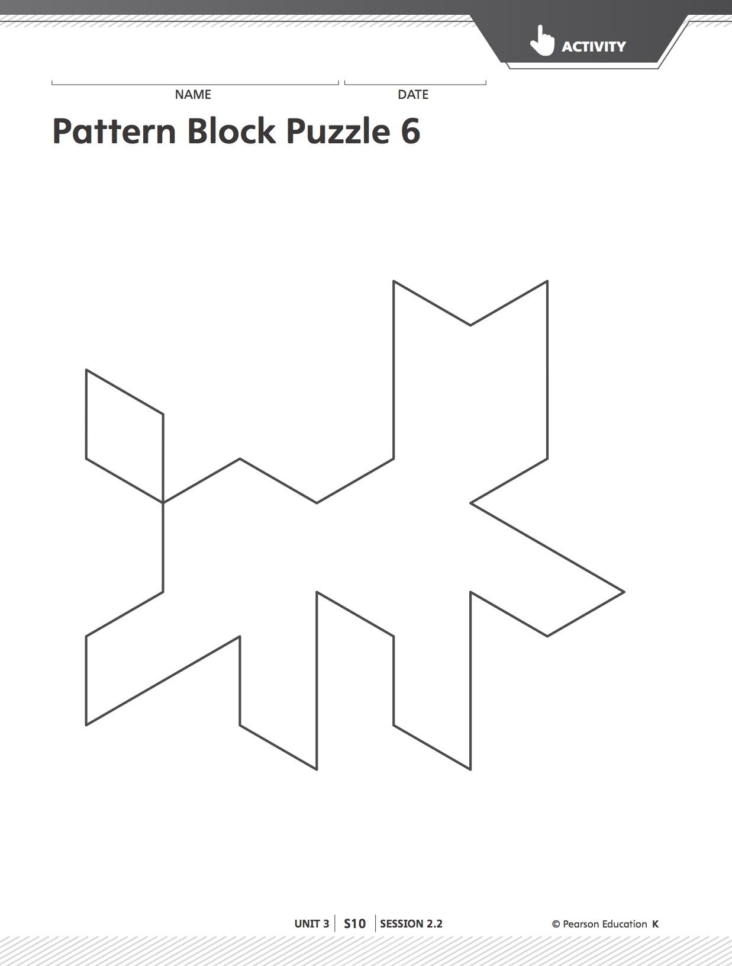

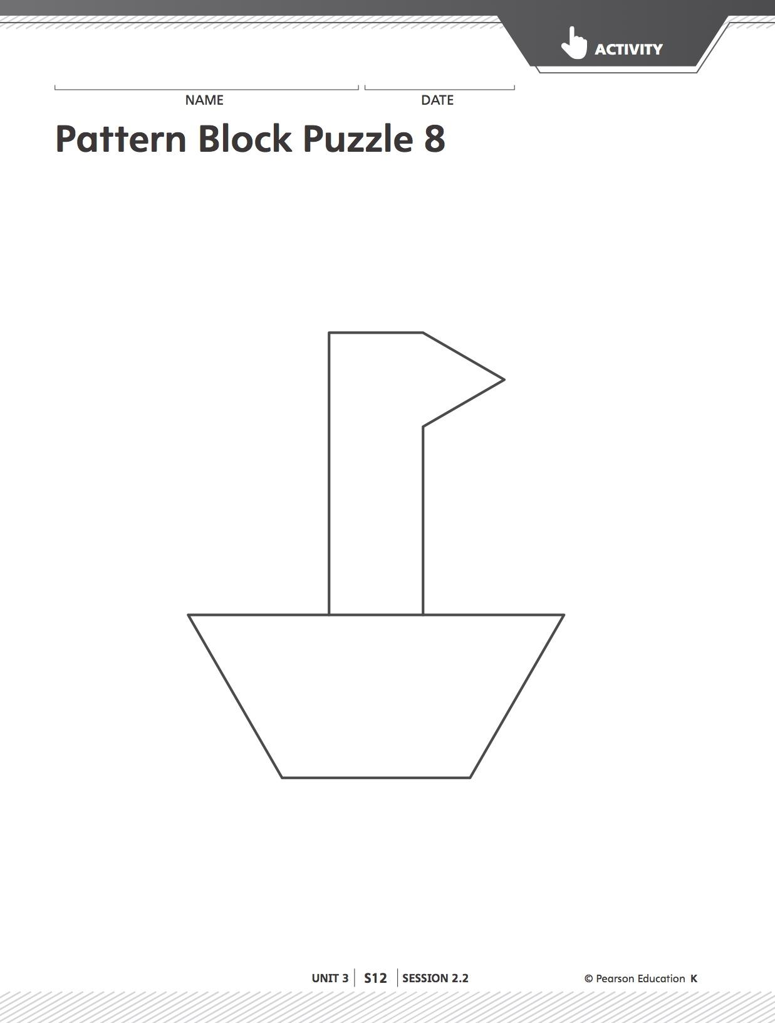

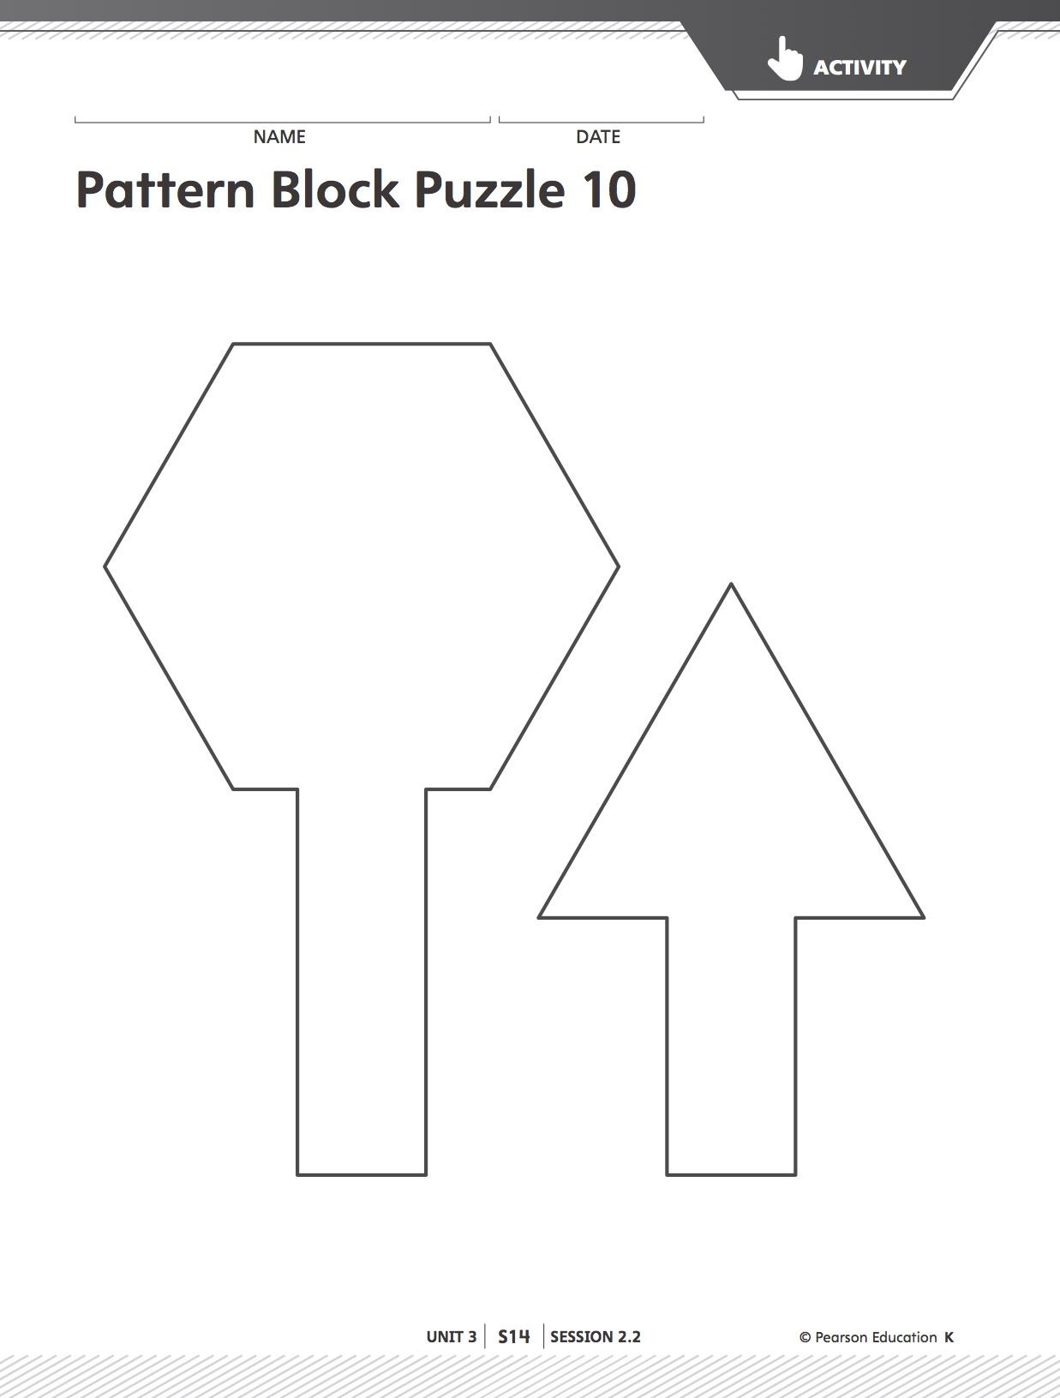
Lesson 5
Making 3D Clay Shapes.

Learning Targets: I can create 3D shapes using clay.
Materials: geoblocks, clay, trays or cardboard pieces
Launch: Ask students to think back to what they made with clay earlier in this unit. Remind them that they made 2D shapes using clay by making clay snakes. Show the students the cylinder from the geoblocks. Ask if anyone remembers the name of this shape. “What are some things that are shaped like a cylinder?” Give examples such as pencil holders, paper towel rolls, cans, etc. Ask if anyone has an idea of how to make a cylinder using clay? Have a student model how to make a clay cylinder. Remind students of the expectations while using clay in the classroom.
Explore: Using what they know about 3D shapes, posters in the room, and geoblocks, have students work to create as many clay shapes as they can. Go around and ask what shapes they are making and discussing the faces on the shapes. Give a 5 minute warning before circling up to make sure each student has a shape to bring to circle.
Share: Like the 2D shapes, help students sort the figures into categories. Compare and contrast shapes within the groups and from different groups.
Summarize: “How are these shapes similar to the 2D shapes we created with clay? How are they different?”
Resource: Investigations in Number, Data, and Space 3. Pearson Education Inc., 2017.

Lesson 6
Build a Cube

Standard: K.3.1.1 Recognize basic two- and three-dimensional shapes such as squares, circles, triangles, rectangles, trapezoids, hexagons, cubes, cones, cylinders and spheres.
Learning Target: I can explain what a cube is. I can make a big cube out of little cubes. I will know I can do it when I show the class my big cube.
Materials: connecting cubes (8 for each child)
Launch: Today we are going to magically turn 8 little cubes into one big cube. Have students brainstorm ideas of why we would need a bigger cube. Could it be helpful if one wanted a higher box to stand on to reach something? What if we wanted to make a box to ship cookies to our grandma?
Explore: Discuss the characteristics of a cube. Ask about number of corners, number of sides, and so on. Allow students time to build their larger cube.
Share: Ask students to discuss how they made their larger cubes. As they are telling about their cubes, ask them leading questions so that they are able to verbalize the steps they took in creating their cube. Ask how many cubes they used. When everyone has had a chance to share with the class, see if the children can think of any ways to make an even larger cube. Guide them so that they start putting their cubes together to make the biggest cube they can. See if they can figure out how many of the tiny cubes they used to create the giant cube.
Summarize: Refer back to the learning target and the “I can” statements. Do the students feel that they have reached their learning target? How do they know? Did they learn anything else about cubes? In the days ahead, keep an eye out for students who may start using geometry in the play areas. Are they making lego shapes related to the math lessons?

Lesson 7
Squares and Cubes

Standard: K.3.1.1 Recognize basic two- and three-dimensional shapes such as squares, circles, triangles, rectangles, trapezoids, hexagons, cubes, cones, cylinders and spheres.
Learning Targets: I can color a square on inch grid paper. I can make a clay cube that is the same size as my colored square. I will know I know it when I put my clay cube on my colored square and see that they are the same size.
Materials: inch grid paper, crayons or markers, clay
Launch: Tell the students that you need a little help. You want to build a cube that fits in a certain area on your desk. You want to put pencils in the cube but you don’t want it to take up too much room. You want your cube to be 4 inches on each side. Ask the students to brainstorm some ideas about how they would make a 4 inch cube.
Explore: Show the students a piece of inch grid paper and give each student a piece of paper. Ask a student to come up and use your paper to color in a 4 inch square. When the students see their pier demonstrating how to color in a 4 inch square, they can then color one in on their paper. Check to make sure all the students have done it correctly. Pass out chunks of clay and see if the students can make a 4 inch cube. Give them plenty of time to create, check, and rebuild if necessary.
Share: As the children create their cubes, have them talk to each other and share ideas. Are they making a solid cube? Are they making 6 flat squares and then constructing a cube? Does one method work any better or worse than another?
Summarize: When the cubes are done being built, have the students leave their creations on their tables. Have the students walk in a line from table to table and without touching, look at what their friends did. Return to the rug and have a class discussion about building a cube. Where all the cubes the same? Where any of them different? Why? Refer back to the learning target. Do the students feel that they have met their learning target of the day? How can they relate this lesson back to the “Build a Cube” lesson that they did yesterday?

Lesson 8
Quarter Turns

Standard: K.3.1.1 Recognize basic two- and three-dimensional shapes such as squares, circles, triangles, rectangles, trapezoids, hexagons, cubes, cones, cylinders and spheres.
Learning Target: I can draw a shape. I can draw the same shape on its side. I will know I know it when I draw my shape on its side.
Materials: paper, pencils, markers, or crayons
Launch: When a student is learning about representations such as written letters, numbers, and shapes, they can be confused when things are turned. For example, a chair is a chair even if you turn is upside down or flip it over. A b can be flipped over and it becomes a d. Turn it upside down and you have a p. Flip that around and you have a q. This lesson is designed to help students see shapes even if they are turned.
Explore: Using a nonsymmetrical shape, model quarter turns. Allow the students time to draw a nonsymmetrical shape and then to draw it turned on its side. They can trade papers with a friend and try to copy their shape. This requires some pretty good small muscle control so be understanding if their shapes are more like blobs. We want them to understand the concept of turns more than we want them to have the skill of drawing a nonsymmetrical shape.
Share: Once the students have draw their shape and a friend’s shape, allow them to share what they have done with the class. Using the document camera will allow all the students to see the examples at the same time. See if the students can identify the shapes.
Summarize: Ask the students if they were able to draw a shape. Where they able to draw the shape on its side? Did anyone try to draw the shape upside down? Ask why it is important to know that a shape stays the same no matter if it is turned.

Lesson 9
Square Search

Standard: K.3.1.1 Recognize basic two- and three-dimensional shapes such as squares, circles, triangles, rectangles, trapezoids, hexagons, cubes, cones, cylinders and spheres.
Learning Target: I can find square in the classroom. I can draw a picture of square items. I will know I can do it when I have shown my friends my drawings and explained their shapes.
Materials: crayons, pencils, or markers, paper
Launch: Model finding and drawing square items around the room, and use descriptive words in explaining your choices.
Explore: Have children draw items around the classroom and that they have at home that are squares, and explain why they fit that sort.
Share: Allow students to show their work on the Smartboard and tell the class why they chose the items that they did. Allow discussion from the other students if they agree or disagree with their classmates’ choices of square items.

Lesson 10
What’s Your Guess

Standard: K.3.1.1 Recognize basic two- and three-dimensional shapes such as squares, circles, triangles, rectangles, trapezoids, hexagons, cubes, cones, cylinders and spheres.
Learning Target: I can reach into a paper bag and name the shape inside without looking at it. I will know I can do it when I show my partner the correct shape.
Materials: pattern blocks, tangrams, paper bags. Each set of partners should have 5 or 6 paper bags, each with a shape in it. The bags can be mixed up so that the same shape may be used more than one time. Using a variety of manipulatives will also make the game more interesting.
Launch: Since the beginning of the year, we have used paper bags with items inside of them for Guided Discovery lessons so the students have practiced reaching in and carefully feeling an item without looking, talking, or ripping the bag. This is a great activity because they should be very successful! The teacher should model the activity by reaching into the bag and doing a “think aloud” where he/she says something to the effect that the object they are feeling has 4 sides and 4 corners. I predict this shape is a square. The the teacher pulls the item out of the bag to show their partner and the partner needs to either confirm or correct the guess.
Explore: Working with a partner, one student reaches into a bag and tells the other student what shape they think they are touching. They that students pulls the shape out of the bag and the partner checks their guess. Then it is the other person’s turn to feel and guess while the first student checks.
Share: Bring the students back to a large group setting and discuss what they learned. Was it easy to guess what the shapes were? What made it easy or hard? How do the students think they could build upon this activity?
Summarize: Did the students feel that they learned the names and attributes of shapes? What else could be put into the bags to be guessed? Lead the conversation to 3-D shapes. What would happen if we put two different shapes in the bag? What if we used read objects instead of pattern blocks? Which objects would they choose?

Lesson 11
Day 1

Title: Marshmallow Shapes (2 day activity)
Day 1

Standard 1: Recognize and sort basic two- and three-dimensional shapes; use them to model real-world objects.
Benchmark:
K.3.1.1 (1.) Recognize basic two- and three-dimensional shapes such as squares, circles, triangles, rectangles, trapezoids, hexagons, cubes, cones, cylinders and spheres.

- I can name and create our shapes.
- I know I have it when I create the shape on my plate and tell my partner what it is.

Vocabulary: 2-D shape names, sides, vertices

Supplies:
- 2-D shape song by Harry Kindergarten
- Toothpicks
- Marshmallows (Gummy Bears can be used also)
- Plates
- 2-D and 3-D Worksheet
- Chart paper, markers
- Picture cards of marshmallow shapes

Launch: How many of you like Rice Krispie Treats? What shape do they come in? When my kids were little I used to make them in many shapes so that they were even more fun to eat. Does anyone know what they are made out of? You are right! It is cereal and marshmallows. That’s why they are so good. We have been working all week on 2-D and 3-D shapes so I thought I would buy some marshmallows and we will create different shaped, pretend, Rice Krispie Bars. Let’s first review our shapes. Turn and talk to your partner about all the shapes we know (list on anchor chart and discuss characteristics of each shape).

Demonstrate directions for building the shapes on their plates. The marshmallows and toothpicks are “tools” and are to be used in that manner. Students must build the shape you ask of them or they may build any shape and tell a friend what it is. Struggling students may use picture cards as aids. Students may use picture cards for self-checking work.

Students will draw out one of their shapes on the 2-D worksheet. Shape name, sides and vertices may be filled in later.

Explore: Students return to desks and begin working with small group on creating shapes. Challenge students as you walk around. (Ex.: What if we add 2 more toothpicks and one more marshmallow? What is the new shape?)

Share: Share with those at your table. Can you name your partner's shape? Can everybody make a different shape and name them? How are they different?

Summarize: Use student work to present to class and discuss the different shapes. How does it compare with our anchor chart? How many sides/vertices? Any new shapes? Fill in the rest of the worksheet from their drawing they made.

Resources:
https://www.teacherspayteachers.com/FreeDownload/FREE-Marshmallow-Shapes-Shape-Building-648087

Harry Kindergarten: 2-D Shapes I Know (song) on YouTube or purchase from web page. http://www.harrykindergartenmusic.com/song/97

Lesson 12
Day 2

Title: Marshmallow Shapes (2 day activity)

Standard 1: Recognize and sort basic two- and three-dimensional shapes; use them to model real-world objects.
Benchmark:
K.3.1.1 (1.) Recognize basic two- and three-dimensional shapes such as squares, circles, triangles, rectangles, trapezoids, hexagons, cubes, cones, cylinders and spheres.

- I can name and create our 3-D shapes.
- I know I have it when I create a shape on my plate and tell my partner what it is.

Vocabulary: shape names, sides, vertices, edges

Supplies:
- 3-D shape song(s)
- Toothpicks
- Marshmallows
- Plates
- 2-D and 3-D Worksheet - optional
- Chart paper, markers
- Solids of 3-D shapes

Launch: I was thinking last night about our shapes we were building in math yesterday and I got an idea. You were all so good at making the 2-D shapes I was wondering if you think it would be possible to build our 3-D shapes the same way? Do you think you can build a (present a solid)? How many sides/faces do we see? How many vertices/corners?

Create an anchor chart with the main shapes. Challenge students to create these shapes at their tables.

Demonstrate one basic shape to students. Explain that they may need to work with a partner to hold some sides while they build together, but to try it on their own first.

Explore: Get into groups and begin creating shapes that are on the anchor chart. Allow students to take solids back to tables for models while trying to construct the 3-D shape.

Share: Share with your neighbors what your shape is. How many sides/edges does it have? How many vertices/corners? How did you build it? What is it called?

Summarize: Use student work to discuss the 3-D shapes. For struggling students, point out and talk about the different 2-D shapes that make up the 3-D shape. Challenge students to put shapes together to build something new (Ex. - house).

Resources:
https://www.teacherspayteachers.com/FreeDownload/FREE-Marshmallow-Shapes-Shape-Building-648087

3D Shapes Song – Shapes for kids – The singing Walrus – youtube.com: https://video.search.yahoo.com/yhs/search?fr=yhs-mozilla-001&hsimp=yhs-001&hspart=mozilla&p=3-d+shape+song#action=view&id=1&vid=709ceb8564adddc6361d087bcdb214e0

It’s a 3-D World! (A song about solid shapes) - youtube.com: https://video.search.yahoo.com/yhs/search?fr=yhs-mozilla-001&hsimp=yhs-001&hspart=mozilla&p=3-d+shape+song#action=view&id=30&vid=e5321934236afbfbde575b7bf6230aa3

Lesson 13

Title: Little Red Hen Shapes Pizza

Standard 1: Recognize and sort basic two- and three-dimensional shapes; use them to model real-world objects.
K.3.1.3 Use basic shapes and spatial reasoning to model objects in the real-world. For example: A cylinder can be used to model a can of soup. Another example: Find as many rectangles as you can in your classroom. Record the rectangles you found by making drawings.

- I can identify a circle, triangle, square, and rectangle
- I know I have it when I can find and count up the number of each shape used on my paper

Vocabulary: Shape names, sides, vertices

Supplies: Construction paper copied with shapes. You may have yellow(cheese) rectangles, red (circle) pepperoni, brown (square) mushrooms, green (triangle) olives.

Launch: Who likes pizza? What are some of the toppings you like? Today we will listen to “The Little Red Hen Makes A Pizza”. Watch carefully for shapes that are seen in the story. Read: The Little Red Hen Makes A Pizza (if you don’t have the book it is on line)
https://search.yahoo.com/yhs/search?p=little+red+hen+makes+a+pizza+video&ei=UTF-8&hspart=mozilla&hsimp=yhs-001

Discuss the shapes you saw in the book. Reread if necessary. Make an anchor chart and review what makes the shape (sides, vertices). Tell students that they will now create their very own pizza. “I will put the meat and vegetables (shapes) at your table to put on your pizza. You must use all of the shapes (meat/vegetable) on your pizza, in different amounts. You may put more on of the things you like.”
Walk around room to make sure students are using all of their shapes. Have them tell you what shape they are using.

Explore (Groups): Students create pizza and fill in their worksheet.
Share: Students should look at their neighbors pizza and paperwork to see if they come up with the same number of shapes as the pizza maker did.
Students should go around and share their work with several classmates.

Summarize: Did anybody get fooled by their neighbors pizza? Were you able to find and count all of the shapes they used? Show some students work to reflect on using different quantities of shapes and how they are all different.

Guiding Questions: Could we have used other shapes for different toppings? What are they? What do they look like(sides,vertices)? Illustrate on chart paper.

Resources:
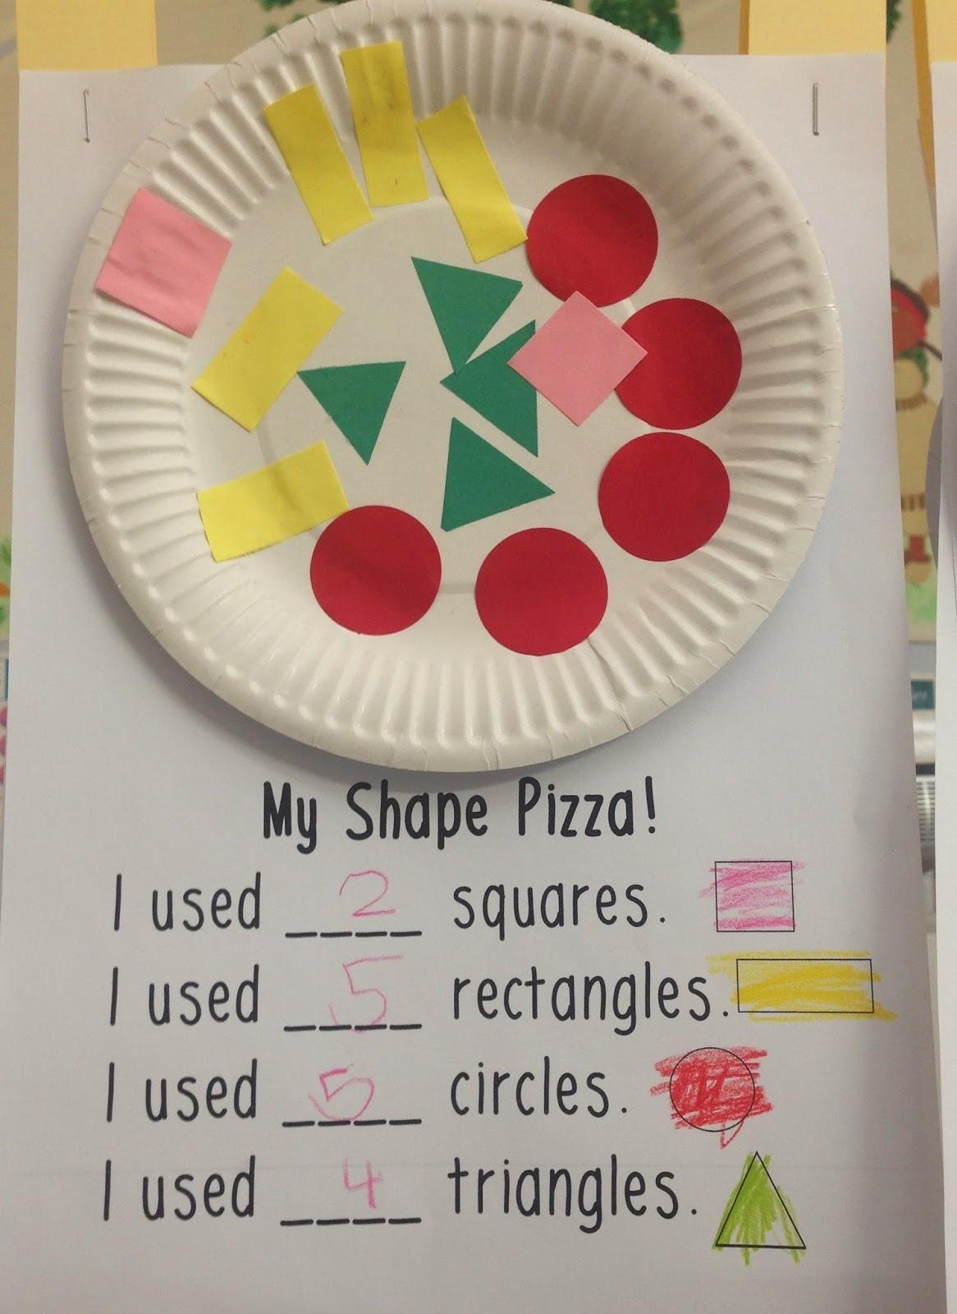https://search.yahoo.com/yhs/search?p=my+shape+pizza+worksheet&ei=UTF-8&hspart=mozilla&hsimp=yhs-001

Staple
Pizza Plate
Here

My Shape Pizza!

I used _____________ squares

I used _____________ rectangles

I used _____________ triangles

I used _____________ circles

Name:____________________________________

Lesson 14

Title: Pattern Block Barrier Game

Standard 1: Recognize and sort basic two- and three-dimensional shapes; use them to model real-world objects.
K.3.1.1 1. Recognize basic two- and three-dimensional shapes such as squares, circles, triangles, rectangles, trapezoids, hexagons, cubes, cones, cylinders and spheres.

- I can identify our common shapes
- I know I have it when I can tell my partner where to place a specific shape

Vocabulary: shape names, positional words

Supplies: divider, barrier grid mats, container of common shapes

Launch: “Last night my kids and I were playing some board games. One of the games we were playing was Battleship. Have you ever heard of that game? (Explain game briefly) We are going to play a game like that but using our shape blocks. What you want to do is put up the divider in front of you so your partner can’t see your mat. Each of you will take a mat. The first person is the captain and they tell the shipmate where to place their blocks on the mat, but the captain has to build his/her mat the same way in order to check and see that the shipmate has done their job correctly. You must say each shape’s name what position to put the block in using positional words (first, second, third, beginning, middle, end).

Before playing the game review all the shapes (sides, vertices) with the students. Demo a round and point out the fact that when you check the shipmate’s work, you must rotate your mat next to theirs to make it match

Explore: Students get into groups of 2 and begin the activity. Listen for proper shape names and positional words being used in the game. After each has had a turn, switch partners.

Share: What was fun about this game? Was anything tricky? Were you able to find all the shapes?

Summarize: Review shapes once more to see if students are able to better identify shapes by name.

Resources:
http://www.k-5mathteachingresources.com/support-files/pattern-block-barrier-game.pdf

Lesson 15

Title: Shapes on the Geoboard

Standard 1: Recognize and sort basic two- and three-dimensional shapes; use them to model real-world objects.
K.3.1.1 1. Recognize basic two- and three-dimensional shapes such as squares, circles, triangles, rectangles, trapezoids, hexagons, cubes, cones, cylinders and spheres.

- I can count the sides and vertices of a shape
- I know I have it when create it on my geoboard

Vocabulary: 2-D shape names, sides, vertices

Supplies:
- Geoboards and rubber bands
- Geoboard grid paper
- Pencils
- Shapes flashcards

Launch: Do you like magic? What is magic? Today I am going to teach all of you magic! Hold up rubberband and ask “What shape is this?” Have you ever seen one shaped any other way than a circle? Do you think rubber bands could be triangle shaped? Demonstrate making a triangle on the geoboard.

Explain to students they will be told a shape to make on their geoboard and then you will place the shape card under the document camera to let them do a self check.

Explore: Get into groups at tables and have students begin with basic shapes you ask for them to create.

Challenge them to try and make circles, ovals, or hearts.

Share: At the tables and under document camera compare the different sizes of shapes they make. How many pegs per side on the compared squares? Are they both still a square?

Summarize: Why doesn’t it work to make circles, ovals, or hearts? How can squares (triangles, rectangles…) be different sizes but still be called a square?

Resources:
http://www.k-5mathteachingresources.com/support-files/shapes-on-the-geoboard.pdf

http://mathatube.com/files/Geoboard-pattern.pdf

http://www.flashcardsforkindergarten.com/shape-flashcards/

References
Works Cited

Lessons 6 - 10 Houghton Mifflin Harcourt, Teacher Edition Volume 1, 2011

Lesson 13 Love, Laughter and Learning in Prep, http://lovelaughterandlearninginprep.blogspot.com/2014_03_01_archive.html

Investigations in Number, Data, and Space 3. Pearson Education Inc., 2017.

https://www.teacherspayteachers.com/FreeDownload/FREE-Marshmallow-Shapes-Shape-Building-648087

https://www.teacherspayteachers.com/FreeDownload/FREE-Marshmallow-Shapes-Shape-Building-648087

http://www.k-5mathteachingresources.com/support-files/pattern-block-barrier-game.pdf

http://www.k-5mathteachingresources.com/support-files/shapes-on-the-geoboard.pdf

http://mathatube.com/files/Geoboard-pattern.pdf

http://www.flashcardsforkindergarten.com/shape-flashcards/

